GAS DETECTOR ALARM

Project description

**PROBLEM SOLUTION**

* In nowdays,gas is the most thing that are used to accomplish many tasks like cooking is most activity that it does .So according to this gas is hazardous classification and flammable which may explosive .Then we need the system which helps us to know that gas is either out or not of its bottle(tank).Therefore “GAS DETECTOR ALARM” is the system which will notifies it.
* As this system is for safety purpose it may be used at home as home security system.

**Introduction**

A gas detector is a device that detects the presence of gases in an area, often as part of a safety system. This type of equipment is used to detect a gas leak or other emissions and can interface with a control system so a process can be automatically shut down. A gas detector can sound an alarm to operators in the area where the leak is occurring, giving them the opportunity to leave. This type of device is important because there are many gases that can be harmful to organic life, such as humans or animals. Gas detectors can be used to detect combustible, flammable and toxic gases, and oxygen depletion.

But in this project, I am using mq5 gas detector sensor with Arduino Nano. The voltage that the sensor outputs changes accordingly to the smoke/gas level that exists in the atmosphere. The sensor outputs voltage that is proportional to the concentration of smoke/gas.

When LPG gas leakage sensed, it will give a HIGH pulse on its DO pin and Arduino constantly reads its DO pin. When Arduino receives a HIGH pulse from the LPG Gas sensor module it's green led turns off and red led turns on with led a 5v buzzer also start beeping until it sense LPG gas.

When Arduino gets a LOW pulse from the LPG Gas detector module, then red led and buzzer turns off and green led turns on.

**Advantages**

* It is cheap (low price).
* Easy to design and implement.

**Components required**

•Arduino uno

•Jumper wires

• 2 220Resistors

•1k Resistor

•MQ5 Gas detector

•Buzzer

**Circuit Diagram**

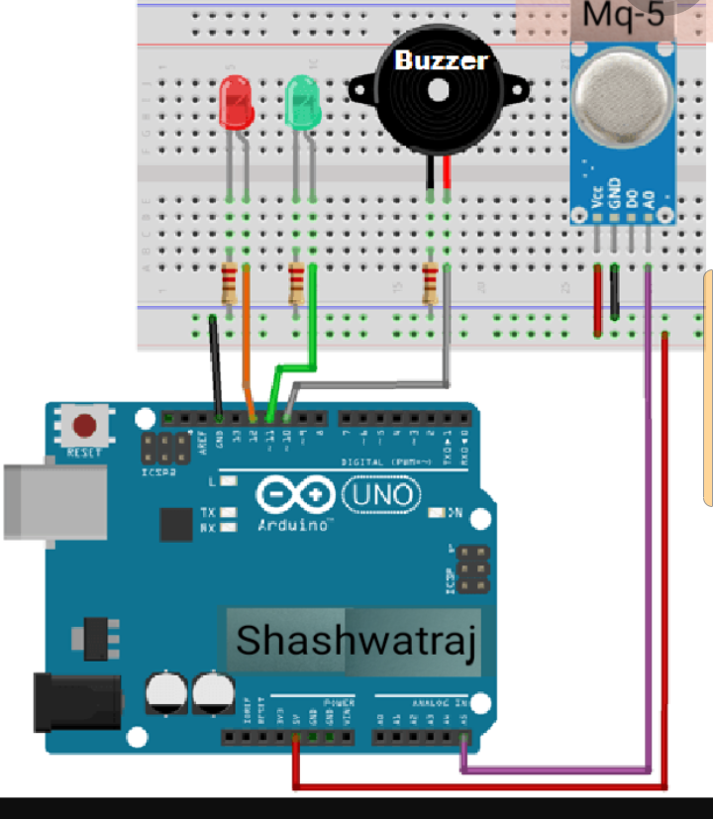

**Arduino codes**

int redLed = 12;

int greenLed = 11;

int buzzer = 10;

int smokeA0 = A5;

// Your threshold value

int sensorThres = 120;

void setup() {

pinMode(redLed, OUTPUT);

pinMode(greenLed, OUTPUT);

pinMode(buzzer, OUTPUT);

pinMode(smokeA0, INPUT);

Serial.begin(9600);

}

void loop() {

int analogSensor = analogRead(smokeA0);

Serial.print("Pin A0: ");

Serial.println(analogSensor);

// Checks if it has reached the threshold value

if (analogSensor > sensorThres)

{

digitalWrite(redLed, HIGH);

digitalWrite(greenLed, LOW);

digitalWrite(buzzer, HIGH);

}

else

{

digitalWrite(redLed, LOW);

digitalWrite(greenLed, HIGH);

digitalWrite(buzzer, LOW);

}

delay(100);

}

**N.B**: I use the smoke detector as gas detector because in our stock there is no availability of gas therefore when you use gas will be detected